Make: Wilkhahn
Model: Multi-purpose chair
Design: Andreas Störiko

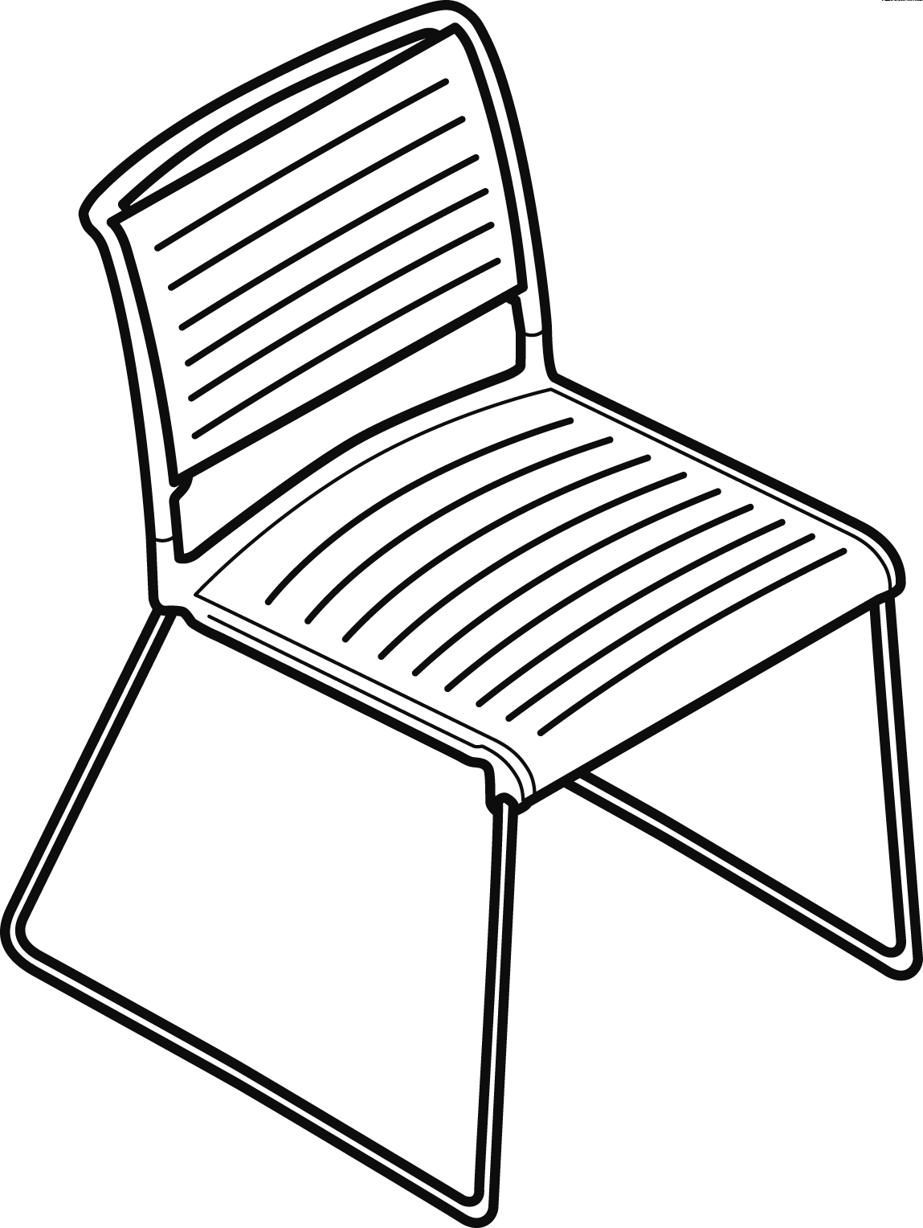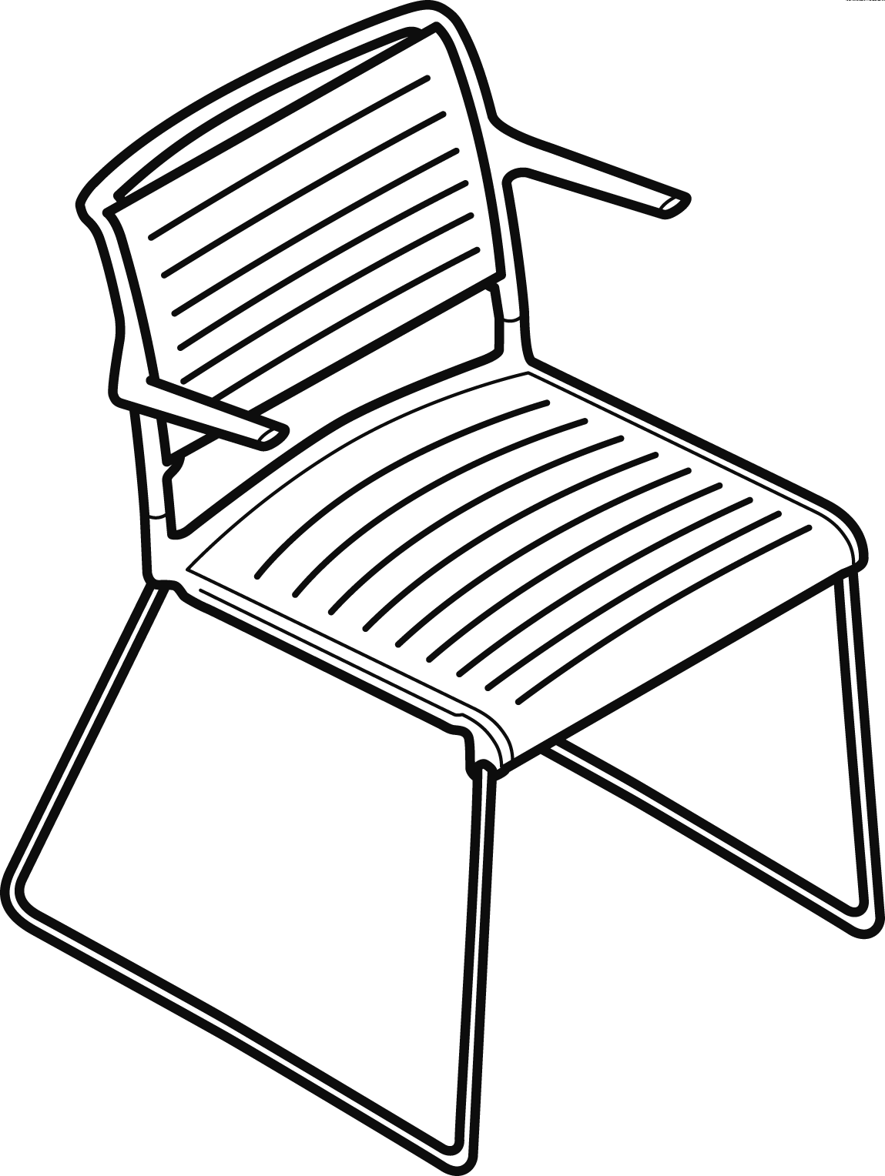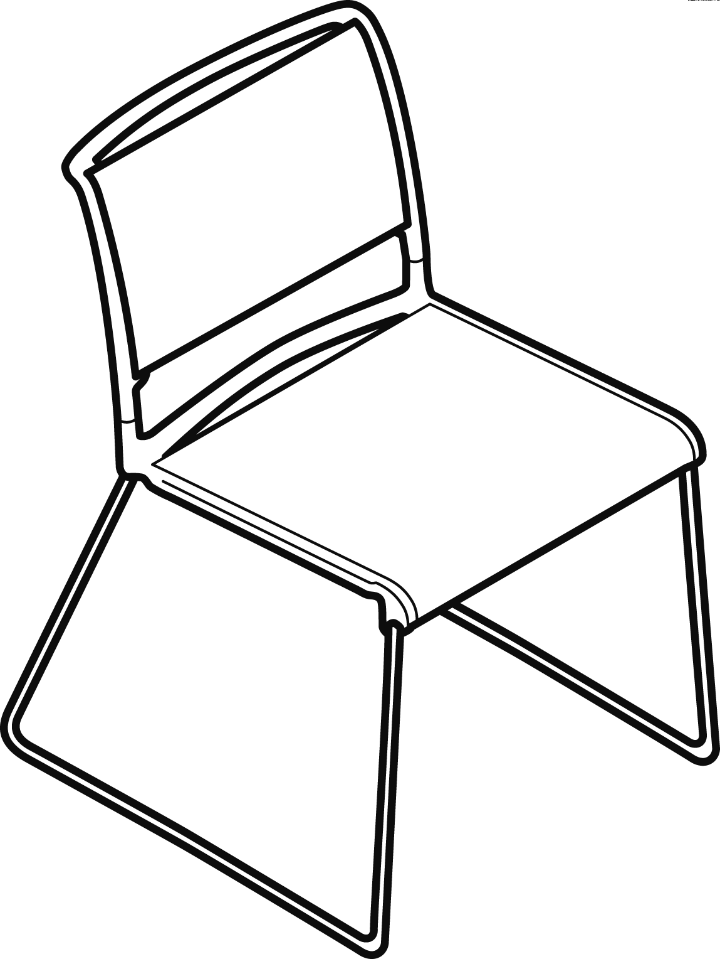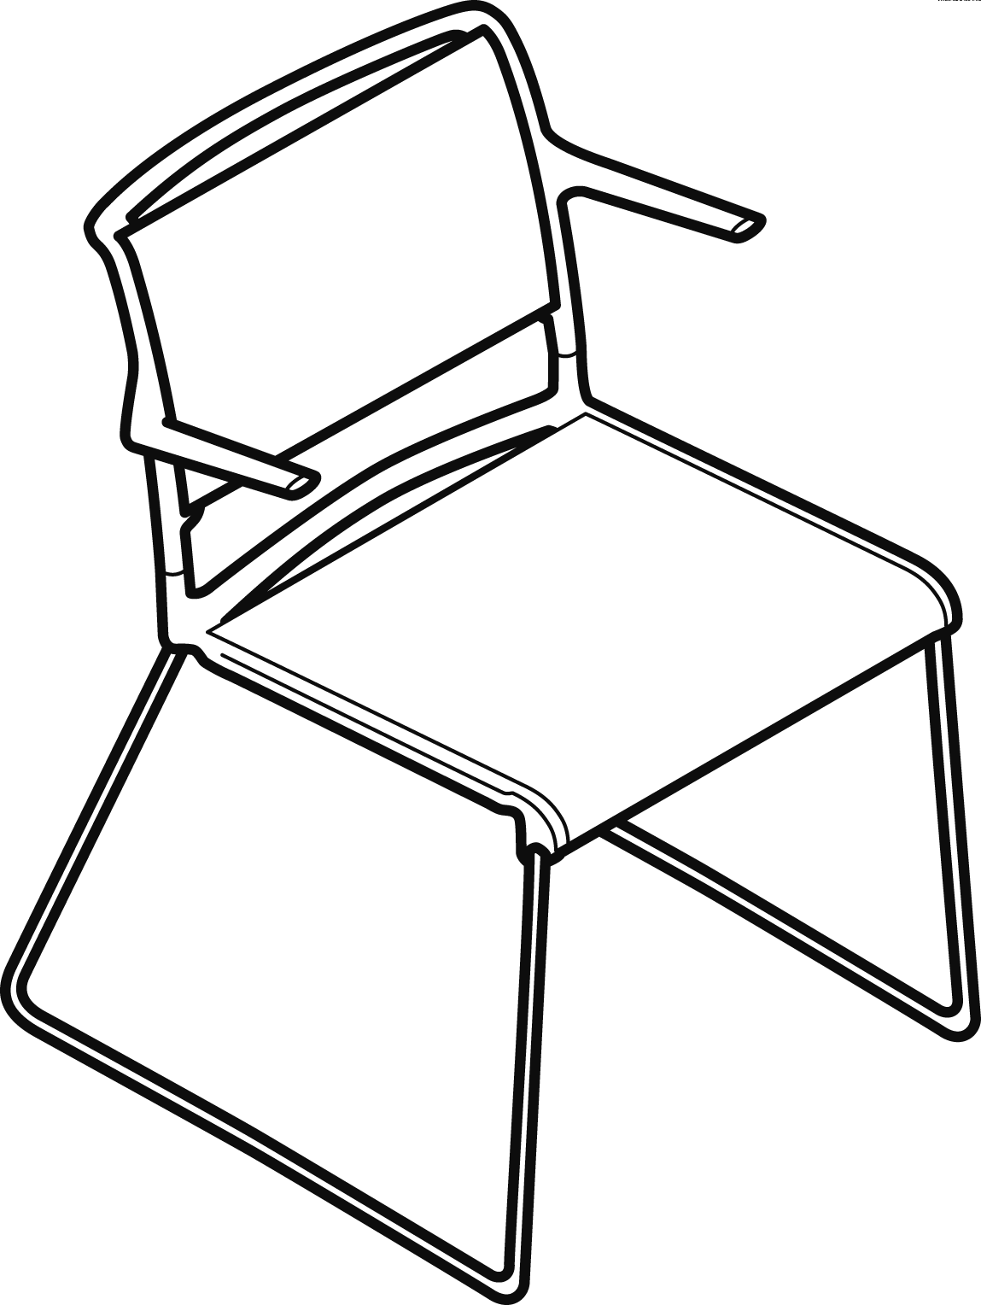

Models:
233/1 Aline-S, seat- and backrest frame with plastic membrane, without armrests
233/2 Aline-S, seat- and backrest frame with plastic membrane, with armrests
230/1 Aline with seat- and backrest covers, without armrests
230/2 Aline with seat- and backrest covers, with armrests

Standards / quality labels:
DIN EN 13761
ANSI/BIFMA X 5.1
DIN EN 16039-L1 (only Aline-S)

Chair dimensions:
Seating height: 44 cm
Total height: 78 cm
Width: 54 cm (without armrests), 59 cm (with armrests)
Depth: 58 cm

Weight:
233/1 without armrests: 5.9 kg (depending on the design, without packaging)
233/2 with armrests: 6.2 kg (depending on the design, without packaging)
230/1 without armrests: 5.1 kg (depending on the design, without packaging)
230/2 with armrests: 5.4 kg (depending on the design, without packaging)

Packaging info:
box sizes for a chair in cm (L x W x H): 74 x 74 x 87
Volume in m³: 0.48

Function:
Lightweight, transparent, stylish and stackable skid-base chair. Compact, form-fit stacking with just 20 mm more space taken per chair due to the special design of the covered seat- and backrest frames. Up to 15 chairs can be stacked free-standing (total height 109 in model 233, 106 cm in model 230), up to 20 chairs can be stacked on a stacking trolley.
(0.72 m² of floor space required [incl. stacking trolley]).
Frame:
skid base made of steel tubing, 12 mm in diameter, bright chrome-plated, supports the seat frame at the front and continues at the rear through the seat frame to the back frame.
Optional: black polyamide glides for soft floorings
Optional: glides with extra felt for flooring that easily scratches.

Seat and back:
Model 233: seat- and backrest frame made of high strength, glass fibre-reinforced polyamide, black or white through-dyed, with plastic membrane made of through-dyed polyamide, colour-matches the seat- and backrest frame. Backrest frame without or with armrests in the same material and colour.
Optional: seat cushion, seat shell made of polypropylene and seat cushion made of cut foam, covered with fabric from the Wilkhahn fabric collection. Not stackable.
Optional: seat cushion, seat shell made of polypropylene and seat cushion made of cut foam, covered with fabric from the Wilkhahn fabric collection. Up to 10 chairs can be stacked, with glass-fibre-reinforced polyamide bumper that colour-matches the seat- and backrest-frame.
Optional: higher backrest (total height: 80 cm)

Model 230: seat- and backrest frame made of very strong, glass fibre-reinforced polyamide, black, grey or white through-dyed, covered with high-performance, coated polyester fabric to colour-match the seat- and backrest frame. Backrest frame without or with armrests in the same material and colour.
Optional: When the seat- and backrest frame are black through-dyed, two-colour cover in copper-black or silver-black.
Optional: seat cushion, seat shell made of polypropylene and seat cushion made of cut foam, covered with fabric from the Wilkhahn fabric collection. Not stackable.
Optional: seat cushion, seat shell made of polypropylene and seat cushion made of cut foam, covered with fabric from the Wilkhahn fabric collection. Up to 10 chairs can be stacked, with glass-fibre-reinforced polyamide bumper that colour-matches the seat- and backrest-frame.
Optional: higher backrest (total height: 80 cm)

Cushioning:
All foam used is CFC-free

Environmental product information:
Material used: plastics: 31.46%, steel 64.91%, others 3.64%
Returns, disassembly and recycling:
All components in the Aline multi-purpose chair are suitable for non-destructive disassembly.
To ensure that materials can be sorted according to type, all components weighing more than 150 g have been labelled accordingly. No agents to protect materials or organic halogen compounds are used which would prevent subsequent recycling. A total of 69 per cent of the chair can be recycled.
For more information see: http://www.wilkhahn.com/green.
The following LEED rating is possible:
LEED CI 5 – 7
LEED NC 4
LEED EB 7

Accessories:
For models 233/1 and 233/2:
inline connectors, only with special multi-purpose glides made of black POM for hard and soft floorings, or with extra felt for flooring that easily scratches.
For models 230/1 and 230/2:
inline connectors, retract automatically underneath the seat, made of matt chrome-plated flat steel, can be retrofitted
Clip for seat and row numbering
All models: chairs with armrests can only be linked alternately with chairs with no armrests.
Four-wheeled trolley for 20 multi-purpose chairs, made of black-coated steel tubing with four ball-bearing mounted wheels for hard and soft floorings, two of which are lockable directional wheels.
Four-wheeled trolley for 16 multi-purpose chairs, made of black-coated steel tubing with four ball-bearing mounted wheels for hard and soft floorings, two of which are lockable directional wheels.
1 sheet of self-adhesive numbers (1-400 for seat- and 1-100 for row numbering)
Outdoor version

Certification and awards:
UN Global Compact
ISO 9001
ISO 14001
EMAS
GREENGUARD™
GREEN STAR GECA

International design awards for the Aline product family:
2005: Design Plus Award, German Design Council, Material Vision, Frankfurt/Main
2006: Red Dot Product Design Award, Designzentrum Nordrhein-Westfalen, Essen
2006: The best of the best, Focus Gold “Energy”, international design price Baden-Württemberg, Design Centre Stuttgart
2007: iF product design award in Gold, Hanover

Wilkhahn reserves the right to make technical changes to the information provided.
Revised December 2015

