Make: Wilkhahn
Model: Timetable folding tables, flip-top, nested storage possible
Design: Andreas Störiko

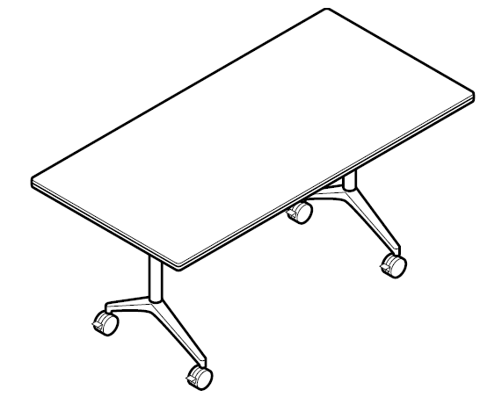

Model:
610 Timetable

Standards:
DIN EN 15372

Table dimensions:
Height to the top edge of the table top: 73 cm
Depth x width: 60 x 140 cm, 60 x 150 cm, 60 x 160 cm, 60 x 180 cm, 70 x 140 cm, 75 x 140 cm, 75 x 150 cm, 75 x 180 cm

Weight:
75 x 150 cm size: approx. 43 kg (depending on the model and design without packaging)

Description:
Mobile table range with flip-top table tops for versatile use in conference, presentation and meeting rooms, as well as in multi-purpose areas and offices
Table feet turn in automatically when flipping the table up
Tables can be nested into one another when flipped up: storage space then required: approx. 9 cm per table (size when stored: clearance between the table tops plus one table top thickness)

Frame:
Polished, die-cast aluminium foot section
Optional: bright, chrome-plated foot section
Uprights and underframes in steel tubing, coated (black or silver satin finish)
Optional: bright, chrome-plated upright
Table top bearer in die-cast zinc, coated black
Black polyamide handles
Lockable and height adjustable swivel castors in black polyamide as the standard version for carpets
Optional: castors made of polyurethane for hard flooring

Table top:
Particle board class E1
Wood lipping all the way round, optionally bullnose or straight, with integral, impact-resilient profile in black elastomer
Edge profiles:
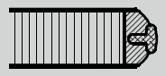
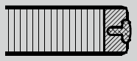

Table top surface:
Table top group 1 – laminate:
Table top thickness 26 mm
Laminate from Wilkhahn colour and surface samples with wood lipping in natural oiled finish

Table top group 2 – veneer:
Table top thickness 26 mm
Variation 1:
Beech, oak and ash veneer according to Wilkhahn woodstain colour samples with wooden lipping, as far as possible in the same colour as the veneer
Variation 2:
Maple, walnut or elm veneer, as well as Wilkhahn mocca veneer from the Wilkhahn colour samples with wooden lipping, as far as possible in the same colour as the veneer
Veneer types:
As a standard, the veneers are produced using the slip-match method
Some specific growth features possible
Surfaces sealed with clear lacquer:
Open-pore: oak, ash, walnut and elm veneer, as well as Wilkhahn Mocca veneer
Closed-pore: maple and beech veneer

Table top group 3: linoleum:
Table top thickness 27 mm
Linoleum from the Wilkhahn colour samples, with laminated beech lipping, natural oiled finish

Optional: A variety of customised options are available on request, shapes, dimensions, surfaces and edges available after feasibility check with Wilkhahn
Special customised designs to suit customer preferences on request after clarifying technical details with Wilkhahn

Environmental product information:
Materials used in size 80 x 160 cm: wood 50.4%, steel 32.8%, aluminium 4.1%, other metals 8.0%, plastics 4.7%
Returns, disassembly and recycling:
All components in the Timetable series are suitable for non-destructive disassembly.
In order to guarantee materials are sorted according to type, all components over 150 g in weight are labelled. No agents to protect materials, or organic halogen compounds are used that prevent recycling at a later date.
A total of 80 per cent of the table can be recycled.
For further information visit: http://www.wilkhahn.com/en/about/corporate-responsibility/

Accessories:
Optional: Modesty panels with aluminium frame, coated with a silver satin finish, covered with transparent anthracite fabric, handles made of black polyamide, modesty panels in lengths of 140 cm, 150 cm, 160 cm or 180 cm
Optional: table-table-connectors (Model 613): two rotatable, lockable clips made of black coated sheet steel with 4 star-grip screws
Optional: cable channel made of aluminium sheet (model 614 for table lengths up to 150 cm, model 615 for table lengths up to 180 cm), can be slotted onto the underframe, black coated, with strain anchor and cable mount, device for optional attachment of horizontal or vertical sockets and data connection units, cable clips made of black, glass fibre-reinforced polyamide to manage the cable on the table frame’s upright
Optional: single table portal Basic: clear anodised aluminium shell with brushed profile, frame placed on the table top, dimensions for single table portal Basic: 300 x 120 mm
Optional: single table portal with brush profile: portal the same colour and material on both sides, flush with the table surface, cut-out section on the table top with genuine wood lipping all around, as far as possible in the same colour as the table top, with hinges that open 180°, single table portal dimensions: 300 x 150 mm
Optional: socket strip (models 708/1, 708/2, 708/4, 708/5), 3-4 modules can be selected with various electricity and/or data configurations, and/or VGA, with the appropriate leads
Optional: integrated techni-station with 3 modules on both sides (model 701/60) or 4 modules (model 701/70), aluminium clear anodised shell, plastic side components colour similar to RAL 9006, black plastic modules, frame attached using a rotary mechanism, ready to connect leads

On request multi-media equipment can be integrated when table top group 3 is chosen

Certification and awards for the Timetable product family (depending on the model):
UN Global Compact
ISO 9001
ISO 14001
EMAS
GREENGUARDTM (undergoing certification)
LEED
The following LEED ratings can be achieved:
LEED CI 5 – 7
LEED NC 4
LEED EB 7

International design awards for the Timetable product family:

2001: Red Dot for top design quality 2001, Design Center NRW
2001: Baden-Württemberg International Design Prize, Design Center Stuttgart
2001: Design Prize Switzerland 2001
2002: iF Product Design Award 2002, Hannover

Wilkhahn reserves the right to make technical changes to the information provided.
May 2015 version

