Make: Wilkhahn
Model: Timetable Smart flip-top folding table, staggered storage possible
Design: Andreas Störiko

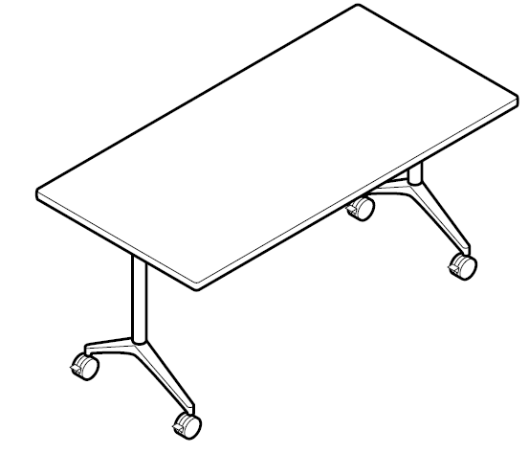

Model:
612 Timetable

Standards:
ANSI/BIFMA X5.5

Table dimensions:
Height to top edge of table top: 73 cm
Depth x width: 60 x 150 cm, 75 x 150 cm

Weight:
75 x 150 cm size: approx. 45.1 kg (depending on the model and design without packaging)

Description:
Mobile table range with flip-top table tops for versatile use in conference, presentation and meeting rooms, as well as in multi-purpose areas and offices
When flipped up nests into other tables, locking mechanism and staggered storage, staggered storage dimensions: approx. 12 cm required per table (staggered storage dimensions: clearance between the table tops plus one table top thickness)

Frame:
Polished, die-cast aluminium foot section
Optional: bright chrome plated
Uprights and underframes in steel tubing, coated (black or silver satin finish)
Steel profile table top bearer, coated black
Draw rod made of round steel tube, coated black
Lockable and height adjustable swivel castors in black polyamide as the standard version for carpets
Optional: castors made of polyurethane for hard flooring

Table top:
Particle board class E1 with melamine resin directly coated (colour optionally light or dark grey)
Straight plastic lipping, colour the same as the surface of the table top (table top group 5)
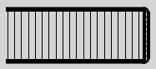

Optional: Particle board class E1
Wood lipping all the way round, bullnose or straight, with integrated impact-resilient profile made of black elastomer (table top group 1, 2, 3)
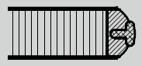
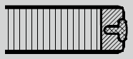

Table top surface:
Table top group 1 – laminate:
Table top thickness 26 mm
Laminate from Wilkhahn colour and surface samples with wood lipping in natural oiled finish

Table top group 2 – veneer:
Table top thickness 26 mm
Variation 1:
Beech, oak and ash veneer from Wilkhahn woodstain colour samples with wooden lipping, as far as possible in the same colour as the veneer
Variation 2:
Maple, walnut or elm veneer, as well as Wilkhahn mocca veneer from the Wilkhahn colour samples with wooden lipping, as far as possible in the same colour as the veneer
Veneer types:
As a standard, the veneers are produced using the slip-match method
Some specific growth features are possible
Surfaces sealed with clear lacquer:
Open-pore: oak, ash, walnut and elm veneer, as well as Wilkhahn Mocca veneer
Closed-pore: maple and beech veneer

Table top group 3: linoleum:
Table top thickness 27 mm
Linoleum from the Wilkhahn colour samples, with laminated beech lipping, natural oiled finish

Table top group 5 – direct coating:
Table top thickness 25 mm
Chipboard with melamine resin with direct coating (colour optionally light or dark grey) with plastic lipping in the same colour as the surface

Optional: A variety of customised options are available on request, shapes, dimensions, surfaces and edges available after feasibility test with Wilkhahn
Special designs to suit customer’s preferences after clarifying technical details with Wilkhahn

Environmental product information:
Materials used in size 75 x 150 cm: wood 44.3%, steel 45.6% aluminium, 4.9%, plastics 5.2%
Returns, disassembly and recycling:
All components in the Timetable Smart series are suitable for non-destructive disassembly.
In order to guarantee materials are sorted according to type, all components over 150 g in weight are labelled. No agents to protect materials, or organic halogen compounds are used that prevent recycling at a later date. A total of 96 per cent of the table can be recycled.
For further information visit: http://www.wilkhahn.com/en/about/corporate-responsibility/

Accessories:
Optional: table-table-connectors (model 613): two rotatable, lockable clips made of black coated sheet steel with 4 star-grip screws
Optional: table-table connectors (model 616): two rotatable clips and two collets made of black through-dyed glass fibre-reinforced polyamide with washers
Optional: cable channel made of aluminium sheet (model 614 for table lengths up to 150 cm) can be slotted onto the underframe, black coated, with strain anchor and cable mount, device for optional attachment of horizontal or vertical sockets and data connection units, cable clips made of black, glass fibre-reinforced polyamide to manage the cable on the table frame’s upright
Optional: single table portal Basic: clear anodised aluminium shell with brushed profile, frame placed on the table top, dimensions for single table portal Basic: 300 x 120 mm
Optional: single table portal with brush profile (not suitable for table top group 5): portal the same colour and material on both sides, flush with the table surface, cut-out section on the table top with genuine wood lipping all around, as far as possible in the same colour as the table top, with hinges that open 180°, single table portal dimensions: 300 x 150 mm
Optional: socket strip (models 708/1, 708/2, 708/4, 708/5), 3-4 modules can be selected with various configurations comprising electricity and/or data, and/or VGA, with the appropriate leads
Optional: integrated techni-station with 3 modules on both sides (model 701/60) or 4 modules (model 701/70), aluminium clear anodised shell, plastic side components colour similar to RAL 9006, black plastic modules, frame attached using a rotary mechanism, ready to connect leads

On request multi-media equipment can be integrated when table top group 3 is chosen

Certification and awards for the Timetable product family (depending on the model):
UN Global Compact
ISO 9001
ISO 14001
EMAS
GREENGUARDTM (undergoing certification)
LEED
The following LEED ratings can be achieved:
LEED CI 5 – 7
LEED NC 4
LEED EB 7

International design awards for the Timetable product family:
2001: Red Dot for top design quality 2001, Design Center NRW
2001: Baden-Württemberg International Design Prize, Design Center Stuttgart
2001: Design Prize Switzerland 2001
2002: iF Product Design Award 2002, Hannover

Wilkhahn reserves the right to make technical changes to the information provided.
September 2014 version

